SQL Practice
Creating Tables and inserting the data:

CREATE TABLE Employee (
emp_id INT PRIMARY KEY,
name VARCHAR(50),
department_id INT,
salary INT,
city VARCHAR(50),
joining_date DATE
);
CREATE TABLE Department (
department_id INT PRIMARY KEY,
department_name VARCHAR(50),
location VARCHAR(50)
);
CREATE TABLE Project (
project_id INT PRIMARY KEY,
project_name VARCHAR(100),
department_id INT,
budget INT
);
INSERT INTO Department
(department_id, department_name, location)
VALUES
(1, 'IT', 'Hyderabad'),
(2, 'HR', 'Chennai'),
(3, 'Sales', 'Bangalore'),
(4, 'Finance', 'Mumbai'),
(5, 'AI', 'Pune');
INSERT INTO Employee
(emp_id, name, department_id, salary, city, joining_date)
VALUES
(101, 'Ravi', 1, 50000, 'Hyderabad', '2022-06-15'),
(102, 'Priya', 1, 70000, 'Chennai', '2021-03-10'),
(103, 'Arun', 2, 40000, 'Hyderabad', '2023-01-20'),
(104, 'Sneha', 2, 60000, 'Chennai', '2020-11-05'),
(105, 'Kiran', 3, 50000, 'Hyderabad', '2022-08-12'),
(106, 'Anu', 3, 80000, 'Bangalore', '2019-07-25'),
(107, 'Rahul', 4, 90000, 'Mumbai', '2018-04-18'),
(108, 'Divya', 4, 65000, 'Pune', '2021-09-30'),
(109, 'Vikram', 5, 85000, 'Pune', '2020-02-14'),
(110, 'Meena', 5, 75000, 'Hyderabad', '2022-12-01'),
(111, 'Suresh', 1, 70000, 'Bangalore', '2023-05-17'),
(112, 'Lakshmi', 3, 50000, 'Chennai', '2024-01-10');
INSERT INTO Project
(project_id, project_name, department_id, budget)
VALUES
(201, 'Banking Application', 1, 500000),
(202, 'AI Chatbot', 5, 800000),
(203, 'Employee Management System', 2, 300000),
(204, 'Sales Dashboard', 3, 450000),
(205, 'Financial Analytics', 4, 600000),
(206, 'Computer Vision System', 5, 900000),
(207, 'Customer Portal', 1, 400000);
SELECT * FROM Employee;

Displaying the Employee Table:

SELECT * FROM Employee;

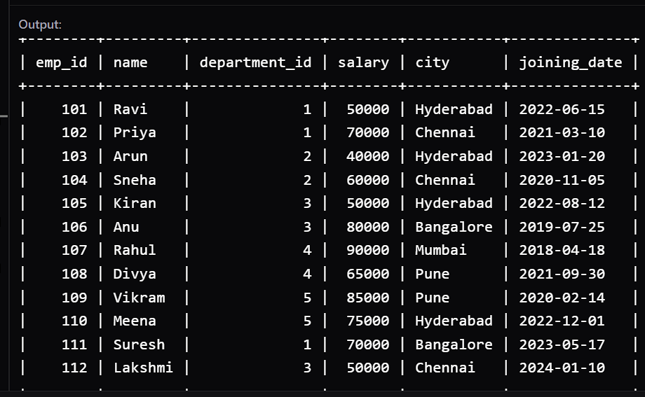

Displaying the Department Table:

SELECT * FROM Department;

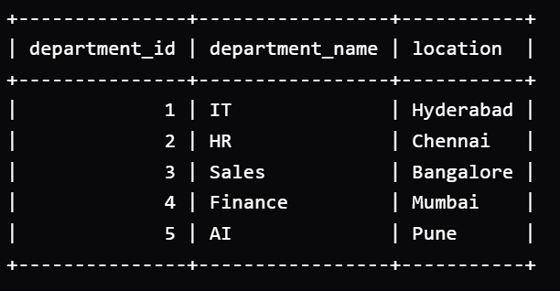

Displaying the project table

SELECT * FROM Project;

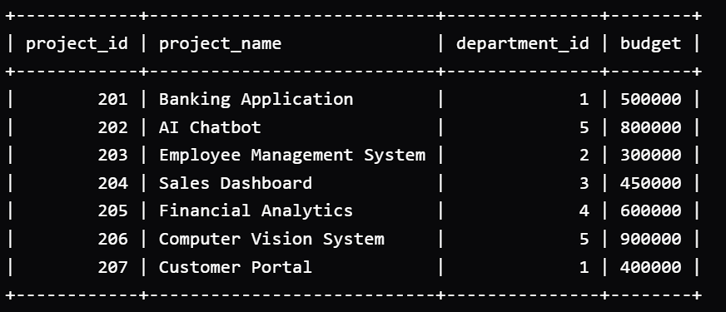

Write a query to display only the employee name, salary, and city of all employees.

select name,salary,city from Employee;

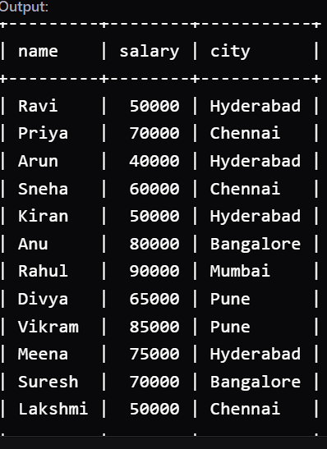

Write a query to display all employees whose salary is greater than 60000

select * from Employee where salary>60000;

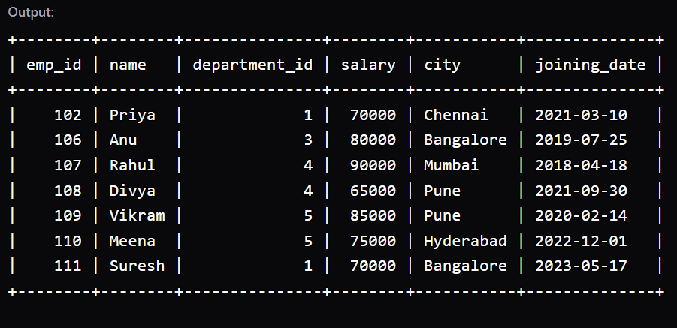

Write a query to display all employees who work in the IT department.

select * from Employee where department_id="1";

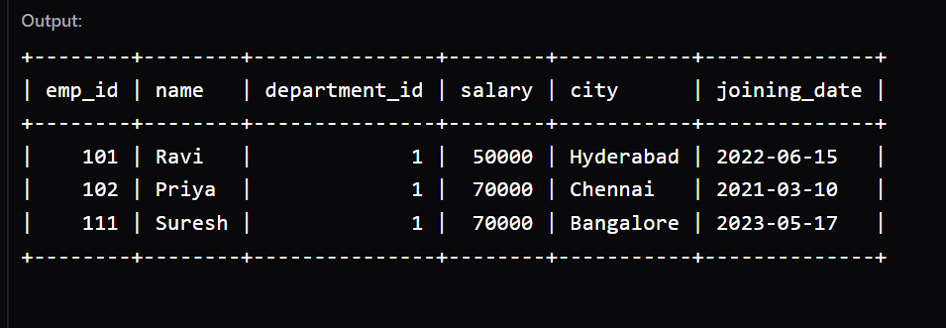

Display employees who are from the IT department AND have a salary greater than 60000.
select * from Employee where department_id=1 and salary>60000;

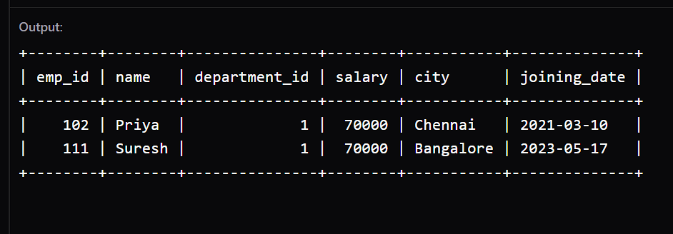

Display employees who belong to IT OR HR.

select * from Employee where department_id=1 or department_id=2;
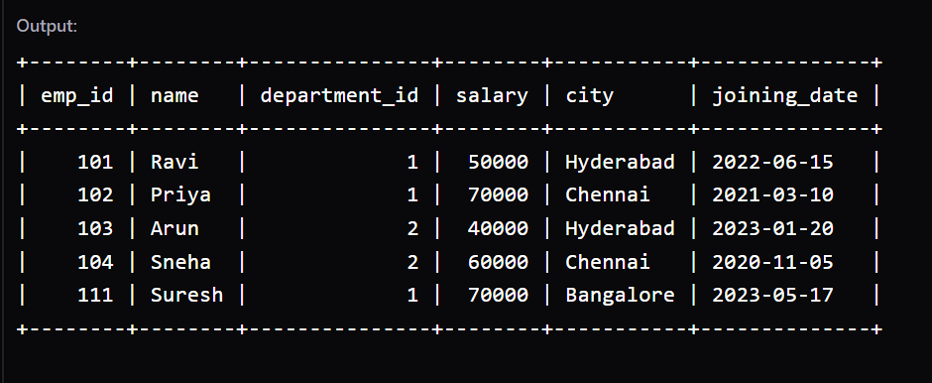

Display employees whose salary is between 50000 and 80000.

select * from Employee where salary between 50000 and 80000;

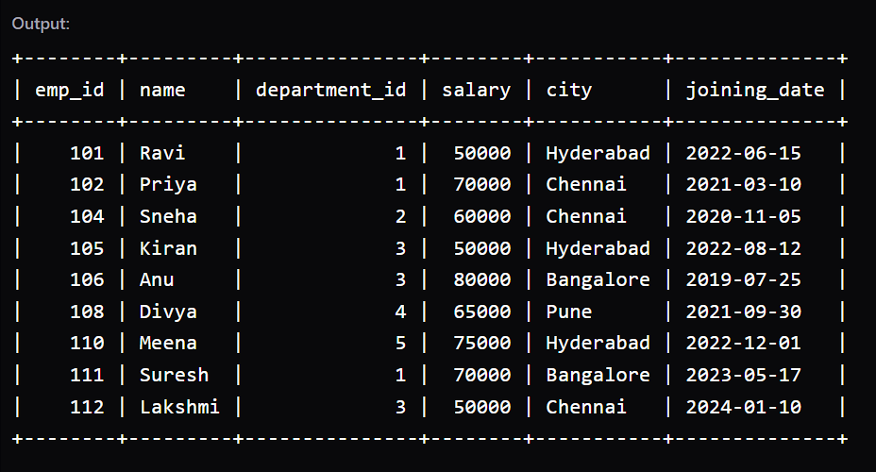

Display employees whose department_id is 1, 3, or 5.

select * from Employee where department_id in(1,3,5);

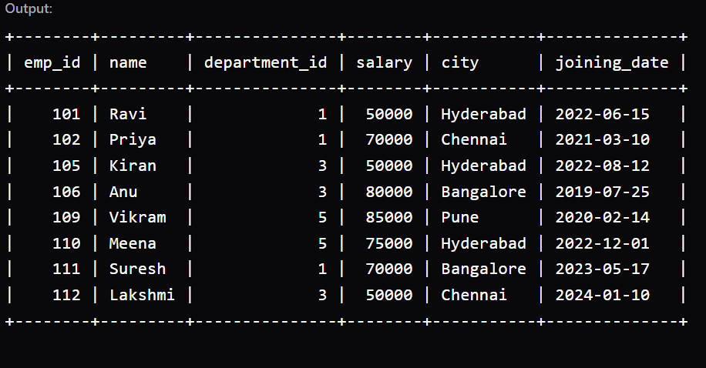

Display all employees whose name starts with the letter A.
select * from Employee where name LIKE "A%";



Display all employees ordered by their salary from highest to lowest.

select * from Employee order by salary DESC;

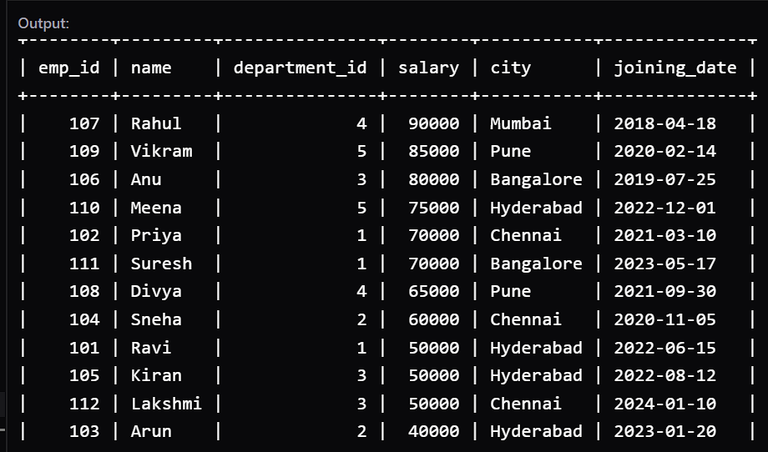

Write a query to find the total number of employees in the Employee table.

select count(*) as total_employees from Employee;

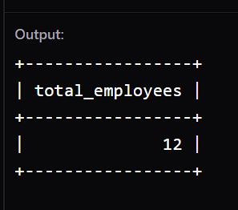

Write a query to find the highest salary among all employees.

select max(salary) as highest_salary from Employee;

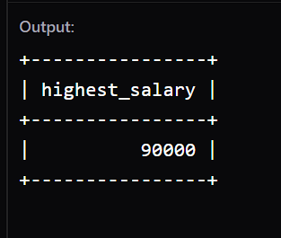

Write a query to find the lowest salary among all employees.
select min(salary) as lowest_salary from Employee;

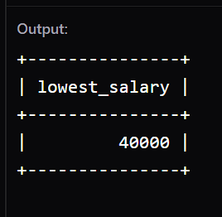

Write a query to find the total salary paid to all employees.

select sum(salary) as total_salary from Employee;

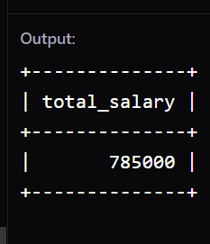

Write a query to find the average salary of all employees.

select avg(salary) as average_salary from Employee;

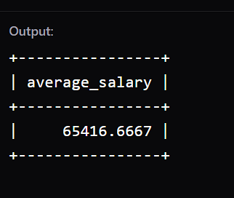

Find the total number of employees in each department.

select department_id,count(*) as total_employees from Employee group by department_id;

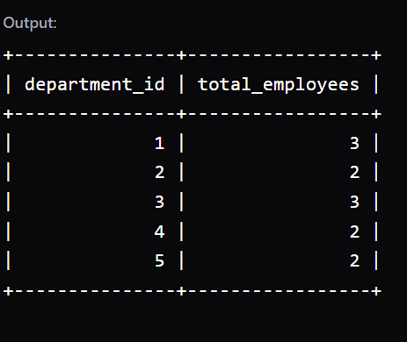

Find the average salary for each department.

select department_id,avg(salary) as average_salary from Employee group by department_id;

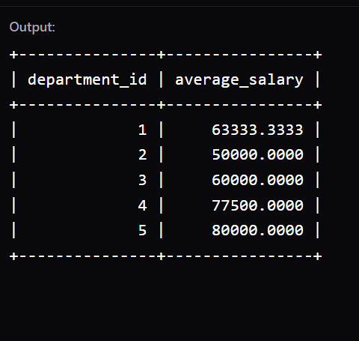

Find the highest salary in each department.

select department_id,max(salary) as highest_salary from Employee group by department_id;

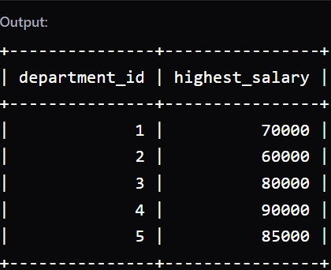

Find the departments where the average salary is greater than 65,000.

select department_id,avg(salary) as average_salary from Employee group by department_id having avg(salary)>60000;

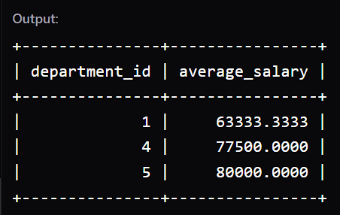

Find the departments that have more than 2 employees.

select department_id,count(*) as no_of_employees from Employee group by department_id having count(*)>2;

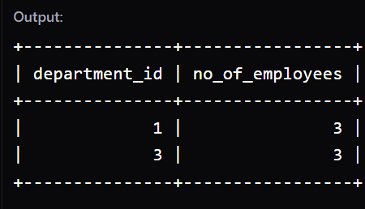

Find the average salary of employees in each department, considering only employees whose salary is greater than 50,000, and display only departments whose resulting average salary is greater than 65,000.

select department_id,avg(salary) from Employee where salary>50000 group by department_id having avg(salary)>65000;

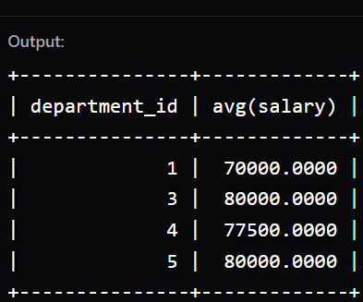

Find the department with the highest average salary.

select department_id,avg(salary) as average_salary from Employee group by department_id order by avg(salary) desc limit 1;

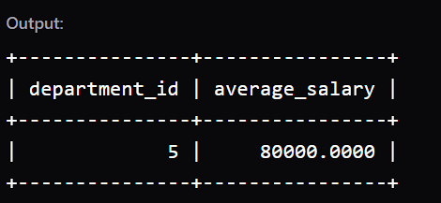

Find the second highest salary from the Employee table.

select distinct salary from Employee order by salary DESC limit 1 offset 1;

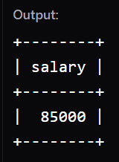

Find the names and salaries of employees whose salary is greater than 60,000, and display them from highest salary to lowest salary.
select name,salary from Employee where salary>60000 order by salary DESC;

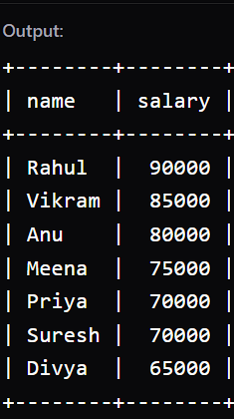

Find the total salary of employees in each department, and display the departments in order of highest total salary first.

select department_id,sum(salary) as total_salary from Employee order by salary DESC group by department_id ;

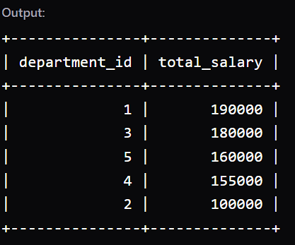

Find the number of employees in each city, but display only cities having more than 1 employee.

select city,count(*) as employees from Employee group by city having count(*)>1;

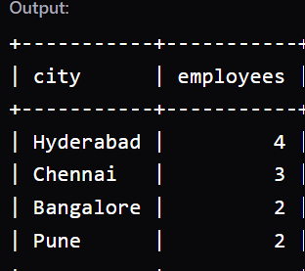

Find the minimum salary in each department, and display only departments where the minimum salary is greater than 40,000.
select department_id,min(salary) as minimum_salary from Employee group by department_id having min(salary)>40000;

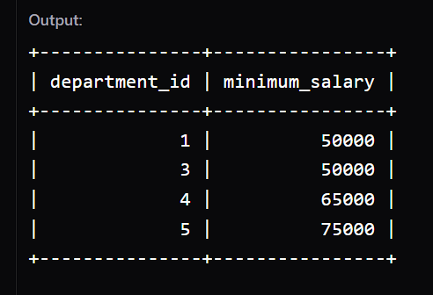

Find the number of employees in each department, and display the result in descending order of the number of employees.

select department_id,count(*) as no_of_emp from Employee group by department_id order by count(*) DESC;

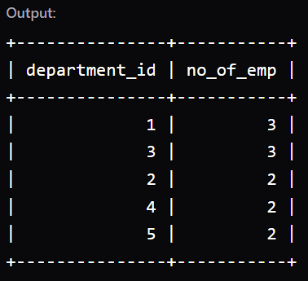

Find the average salary of employees in each city, but consider only employees whose salary is greater than 50,000. Display the cities from highest average salary to lowest average salary.

select city,avg(salary) as average_s from Employee where salary>50000 group by city order by average_s DESC;

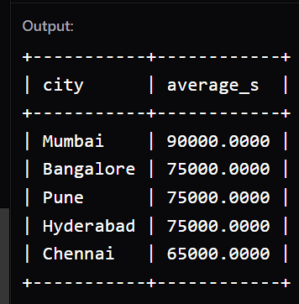

Find the department IDs where the total salary is greater than 200,000, and display them from highest total salary to lowest.

select department_id,sum(salary) as total_salary from Employee group by department_id having sum(salary)>200000 order by total_salary DESC;

NOTHING IS THERE

Find the second-highest salary from the Employee table without using LIMIT or TOP.

select max(salary) as sec_highest_salary from Employee where salary<(select max(salary) from Employee);

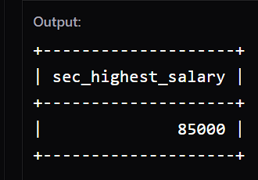

Find the highest salary in each department, and display the department ID and highest salary.
select department_id,max(salary) from Employee group by department_id;

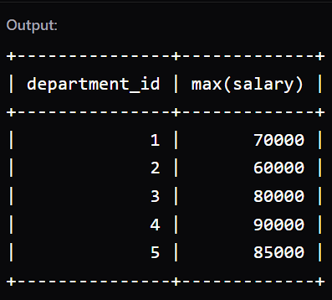

Find the employee name and salary of the employee who has the highest salary in the company.

select name,salary from Employee order by salary desc limit 1;

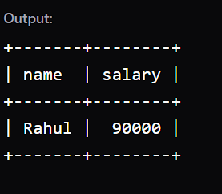

Find the employees whose salary is greater than the average salary of all employees.

select * from Employee where salary>(select avg(salary) from Employee);

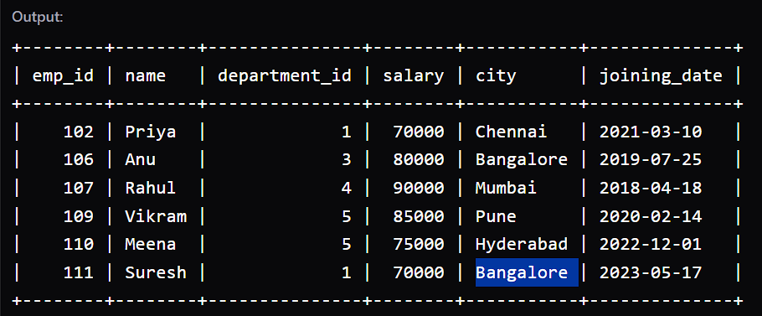

Find the employees who earn the highest salary in their department.

SELECT * FROM Employee e WHERE salary = (SELECT MAX(salary) FROM Employee WHERE department_id = e.department_id);

